Real-Time Event Management System
A Project Based Learning Report Submitted in partial fulfilment of the requirements for the award of the degree
of
Bachelor of Technology
in The Department of AI & DS
Project Based Learning (PBL)
Submitted by
2510080046: M. BALAJI
2510080056: RUTHVIK
2510080054: KRITHIK REDDY
2510080060: KARTHIKEYA
Under the guidance of
Dr. Laiphangbam Melinda

Department of AI & DS
Koneru Lakshmaiah Education Foundation, Aziz Nagar
Aziz Nagar - 500075
OCT - 2026.
Abstract
Organising campus events with separate announcements, registration forms and paper attendance sheets is slow, error-prone and gives organisers no live picture of an event. This project presents the Real-Time Event Management System (EventHub), a full-stack web application that manages the complete event lifecycle: event creation, participant registration with capacity control, QR-based attendance, notifications and real-time analytics. The frontend is built with React.js, Vite and Tailwind CSS, the backend is a Node.js and Express.js REST API with Socket.IO for live updates, and all data is stored in a PostgreSQL relational database.
The system provides two role-based portals. Students can browse published events, register while seats are available and download a unique QR ticket. Organizers can create and publish events, scan QR tickets at the venue to record attendance, and watch registrations, attendance and capacity on a live dashboard. Business rules are enforced on the server using validated inputs, unique constraints and row-level locking inside transactions, so an event cannot be over-booked, a student cannot register twice for the same event and a ticket cannot be used twice.
The report describes the problem, the design of the architecture and database, the backend and frontend implementation, the experiments and the results, and suggests future enhancements such as stronger authentication, payments, certificates and external notifications.
Functional testing of ten scenarios, covering event creation, registration, capacity validation, QR verification, duplicate prevention, database operations, API requests, dashboard updates, notifications and analytics, produced the expected result in every case. The results show that centralising event data, replacing manual attendance with QR check-in and providing real-time visibility improve accuracy, efficiency and scalability of event management.
List of Figures
Figure 1: Development workflow of the project
Figure 2: Three-tier system architecture with real-time layer
Figure 3: Use-case diagram
Figure 4: Entity-relationship diagram of the database
Figure 5: Level 0 data flow diagram (context diagram)
Figure 6: Level 1 data flow diagram
Figure 7: Flowchart of the QR check-in process
Figure 8: Sequence diagram of registration and QR check-in
Figure 9: EventHub Portal Access: role-based login page
Figure 10: Student portal home page showing published events
Figure 11: Create New Campus Event form (organizer)
Figure 12: Registration and QR ticket screen (student)
Figure 13: QR attendance check-in screen (organizer)
Figure 14: Live analytics dashboard (organizer)
List of Tables
Table 1: Comparison of event management approaches
Table 2: Functional requirements
Table 3: Non-functional requirements
Table 4: Hardware and software requirements
Table 5: Technologies and tools used
Table 6: Structure of the users table
Table 7: Structure of the events table
Table 8: Structure of the registrations table
Table 9: Structure of the attendance table
Table 10: Structure of the notifications table
Table 11: Implementation modules and status
Table 12: REST API endpoints
Table 13: Request and response details of the main endpoints
Table 14: HTTP status codes used by the API
Table 15: Experimental environment
Table 16: Sample data used in the experiments
Table 17: Test procedures
Table 18: Functional test cases and results
Table 19: Result summary
Table 20: Screens of the working application
Table 21: Before and after: manual process versus the developed system
Table 22: Challenges and solutions
Table 23: Glossary of terms and abbreviations
Table of Contents
1. Introduction
a. Background
b. Problem Statement
c. Need and Motivation
d. Objectives
e. Scope and Limitations
f. Comparison with Existing Approaches
g. Feasibility Study
h. Organisation of the Report
2. Methodology
a. Development Approach
b. Requirement Analysis
c. Hardware and Software Requirements
d. Technology Stack
e. System Architecture
f. Use Cases
g. Database Design
h. Normalisation and Integrity Constraints
i. Indexes and Query Design
j. Data Flow
k. Module Description
l. Backend Design
m. API Specification
n. Registration, Capacity Control and QR Check-In Logic
o. Real-Time Updates with Socket.IO
p. Frontend Design
q. Implementation of Key Parts
r. Security and Configuration
3. Experiments
a. Experimental Setup
b. Test Data
c. Test Plan
d. Detailed Test Procedures
e. API Request and Response Examples
f. Result Observation
g. Frontend Verification
4. Results
a. Functional Results
b. Summary of Results
c. Description of the Screens
d. Impact: Before and After
e. Discussion
f. Working Procedure (User Guide)
g. Challenges Faced and Solutions
h. Lessons Learned
5. Conclusion and Future Work
a. Conclusion
b. Future Work
References
Appendix A: Backend Source Code
Appendix B: Frontend Source Code
Appendix C: Installation and Execution Guide
Appendix D: API Test Commands
Appendix E: Glossary

1. Introduction

a. Background
Colleges and universities organise a large number of events every year: technical workshops, hackathons, guest lectures, cultural programmes and competitions. In many institutions the whole life of an event is handled with scattered tools. Announcements are posted on notice boards or messaging groups, registrations are collected through paper forms or separate online forms, attendance is taken on a printed sheet, and the final report is compiled by hand. Because each step is handled separately, the information is duplicated, easily becomes inconsistent, and is available to the organiser only after the event is over.
A web-based information system can bring all of these steps into one place. When event details, registrations and attendance are stored in one relational database, every user sees the same data, rules such as seat capacity can be applied automatically, and organisers can monitor an event while it is running instead of after it has finished. Modern web technologies also make it possible to push updates to the browser the moment they happen, which is what is meant by "real-time" in the title of this project.
This project, the Real-Time Event Management System (branded EventHub in the user interface), is a full-stack web application. The presentation tier is a single-page application built with React.js, Vite and Tailwind CSS. The application tier is a Node.js and Express.js backend that exposes a REST API using JSON and pushes live updates over Socket.IO. The data tier is a PostgreSQL database. Students can browse published events, register, and download a QR ticket; organisers can create and publish events, scan QR tickets at the entrance, and watch registrations and attendance on a live dashboard.

b. Problem Statement
Campus event administration depends on three kinds of information: what events exist and how many seats they have, who has registered for them, and who actually attended. When these are kept in separate forms, sheets and registers, organisers cannot easily tell how many seats are left, the same person can register twice, attendance sheets are slow to fill and prone to errors or proxy entries, and nobody has a live picture of the event. Reports must be prepared manually after the event, which delays decisions.
The problem addressed in this project is therefore to build a centralised, validated and easy-to-use platform that manages the complete event lifecycle, from creation to registration, QR-based attendance and analytics, stores all data in a relational database, enforces capacity and duplicate-registration rules automatically, and shows organisers up-to-date participation figures in real time.

c. Need and Motivation
Events are central to student life, yet organisers often spend more time on paperwork than on the programme itself. Manual attendance in particular is slow at the entrance, can be falsified, and cannot be verified later. A QR ticket that is generated at registration and scanned at the venue gives every participant a unique, verifiable proof of registration and gives the organiser an accurate attendance record in seconds. Real-time dashboards remove the delay between what is happening at the venue and what the organiser knows.
The project also serves an academic purpose. It brings together relational database design, REST API development, component-based frontend development, WebSocket communication and transaction handling in one working application, and shows how these topics cooperate in a complete system instead of as isolated exercises.

d. Objectives
- To provide a centralised platform for event creation, information management and end-to-end lifecycle coordination (Event Lifecycle Management).
- To record attendance through digital QR check-in so that attendance is accurate, verifiable and available in real time (QR-Based Attendance).
- To offer real-time dashboards, notifications and performance insights to organisers and participants (Analytics and Reporting).
- To design the system so that it can serve academic, professional and competitive events, with capacity tracking and centralised data (Scalable and Adaptable).
- To prevent duplicate registrations and over-booking by enforcing rules on the server and in the database.
- To integrate a React frontend, an Express backend and a PostgreSQL database into one working, deployed system.

e. Scope and Limitations
The implemented scope covers six modules: Event Management, Registration and Capacity, QR Attendance, Notifications, Analytics Dashboard and Database Management. Two kinds of users are supported through separate portals: Students, who browse and register for events and download QR tickets, and Organizers, who create and publish events, scan tickets and view analytics. The interface supports a dark theme and is usable on desktop and mobile browsers.
The current version has some limitations. Payments for paid events, certificate generation, email or SMS delivery of notifications outside the application, and integration with the institutional single sign-on are not included. The one-click demo login shown on the login page is intended for demonstration and would be removed or restricted in a production deployment. These points are listed as future work in Section 5.

f. Comparison with Existing Approaches
Table 1 compares the proposed system with the methods most commonly used to run campus events. The comparison is qualitative and based on the features each approach can realistically offer.
Table 1: Comparison of event management approaches
Feature | Paper / notice board | Generic online forms + spreadsheet | Proposed system
Single shared copy of data | No | Partly | Yes (PostgreSQL)
Seat capacity enforced | No | Manual or limited | Yes (server-side, transactional)
Duplicate registration prevented | No | Partly | Yes (checked on server and by index)
Attendance method | Signature sheet | Manual tick | Digital QR scan
Proof of registration | None | Confirmation email | Unique QR ticket
Live view for organiser | No | No | Yes (Socket.IO dashboard)
Notifications | Notice board | Manual email | In-app, automatic
Cost and effort to set up | Low | Low | Moderate (one time)

g. Feasibility Study
Technical feasibility: every component (React, Vite, Tailwind CSS, Node.js, Express, Socket.IO and PostgreSQL) is mature open-source software with extensive documentation, runs on an ordinary laptop, and can be deployed on free or low-cost hosting. The team already knew JavaScript, so no specialised hardware or new infrastructure was needed.
Economic feasibility: there is no licence cost for any tool, and development and testing used only the team's own computers. The frontend can be hosted on a static hosting service (the demonstration build is served through Netlify) and the backend and database on a single small server.
Operational feasibility: the interface uses plain language, icons and familiar patterns such as tabs, cards and forms, so a student or an organiser can learn it within a few minutes. The system replaces existing manual steps rather than adding new ones.
Schedule feasibility: because the work was divided into independent stages (requirements, system design, database design and module development) and reviewed at fixed review points, the working system was completed within the semester.

h. Organisation of the Report
Section 1 introduces the problem, objectives and scope. Section 2 describes the methodology: development approach, requirements, technology stack, architecture, database design, backend and frontend design and selected source code. Section 3 explains the experimental setup and the test cases. Section 4 presents and discusses the results, including the screens of the application. Section 5 gives the conclusion and future work, followed by the references and appendices.

2. Methodology

a. Development Approach
The project followed a modular, iterative approach shown in Figure 1. The lifecycle has four development stages, Requirements, System Design, Database Design and Module Development, followed by integration and testing. In the requirements stage the team identified the entities to be managed (users, events, registrations and attendance) and the rules that must hold, such as "no registration beyond seat capacity" and "one registration per student per event". In the design stages these were converted into a layered architecture and a set of related PostgreSQL tables. In the development stage the Express API, the React interface and the real-time layer were built and connected using JSON over HTTP and WebSockets.
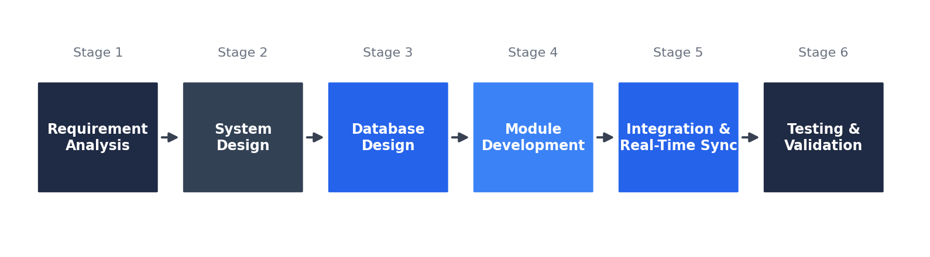
Figure 1: Development workflow of the project
Modular development allowed each component to be implemented independently and integrated progressively, so that every stage could be validated before the next one was added. The functional workflow of the finished system follows five steps: (1) Event Creation, (2) Participant Registration, (3) QR Code Generation and Check-In, (4) Attendance Recording and Database Storage, and (5) Real-Time Dashboard and Analytics. Version control with Git and GitHub was used throughout so that the four team members could work on the frontend, backend and database in parallel.

b. Requirement Analysis
The functional requirements describe what the system must do. They were derived from the day-to-day tasks of event organisers and participants and are listed in Table 2. Each requirement is covered by at least one API endpoint and one screen of the frontend.
Table 2: Functional requirements
ID | Requirement | Module
FR1 | Authenticate users and provide separate portals for Students and Organizers | Authentication
FR2 | Create and publish an event with title, category, capacity, date, timing, venue, host and description | Event Management
FR3 | Display all published events to students as cards with category and status | Event Management
FR4 | Register a student for an event while seats are available | Registration
FR5 | Reject a registration if the event is full or the student is already registered | Registration
FR6 | Generate a unique QR ticket for every confirmed registration and allow download | QR Attendance
FR7 | Scan a QR ticket at the venue, verify it and record attendance once | QR Attendance
FR8 | Send automatic alerts: registration confirmation, event updates, reminders and check-in | Notifications
FR9 | Show registrations, attendance, capacity and event performance on a dashboard | Analytics
FR10 | Update dashboards and notification counters in real time without reloading the page | Real-Time Updates
FR11 | Report clear success and error messages to the user | All

The non-functional requirements, listed in Table 3, describe the quality expected from the system: correctness of data, responsiveness, usability on different screen sizes and ease of maintenance.
Table 3: Non-functional requirements
Attribute | Requirement
Data integrity | No seat may be sold beyond capacity; no student may hold two confirmed registrations for one event; a QR ticket may be used only once
Real-time behaviour | Dashboard figures and notification counters update within moments of the underlying change
Usability | Simple role-based navigation, forms with required fields, immediate feedback and a dark / light theme toggle
Responsiveness | Layout adapts to desktop and mobile widths
Security | Role-based access, parameterised SQL, validated inputs and credentials kept outside source code
Maintainability | Separate frontend and backend; modular services; one route per operation
Portability | Runs on any system with Node.js and PostgreSQL; frontend deployable on static hosting

c. Hardware and Software Requirements
Table 4 lists the recommended hardware and software for running the system. The requirements are modest because the data volume of a campus event system is small.
Table 4: Hardware and software requirements
Item | Requirement
Processor and memory | Dual-core processor, 4 GB RAM or more
Storage | About 1 GB free (project, node_modules and database)
Operating system | Windows, Linux or macOS
Node.js | Node.js and npm with Express, Socket.IO, node-postgres (pg), cors and dotenv
Frontend tooling | React.js, Vite, Tailwind CSS, a QR code generation library and a QR scanner library
Database | PostgreSQL server (default port 5432)
Browser | Any modern browser such as Chrome, Edge or Firefox; camera access for QR scanning

d. Technology Stack
The technologies, summarised in Table 5, were chosen because they are widely used, well documented and free. React makes it easy to build interactive screens from reusable components, Vite provides a very fast development server, and Tailwind CSS speeds up consistent styling. Node.js with Express gives a short path from request to JSON response and shares one language (JavaScript) with the frontend. PostgreSQL offers strong support for constraints, transactions and row-level locking, which are central to capacity enforcement.
Table 5: Technologies and tools used
Layer | Technology | Purpose
Frontend | React.js, Vite, Tailwind CSS | Single-page user interface, development server and styling
Backend | Node.js, Express.js | REST API and business logic
Database | PostgreSQL | Relational storage of users, events, registrations and attendance
APIs | REST API + JSON | Communication between frontend and backend
QR / Attendance | QR code generation + QR scanner | Ticket creation and check-in at the venue
Real-time | Socket.IO | Live push of dashboard and notification updates
Version control | Git, GitHub | Source control and team collaboration
Hosting (demo) | Netlify | Static hosting of the frontend build

e. System Architecture
Figure 2 shows the architecture. Users (students and organisers) interact with the React frontend in the browser. Every user action is sent through the API layer to the Express backend, which is organised as independent services for events, registration, attendance, notifications and analytics. Each service handles its own logic and then persists the data in the centralised PostgreSQL database. A real-time processing layer based on Socket.IO continuously synchronises the dashboard and analytics view, so organisers always see live participant and attendance data.
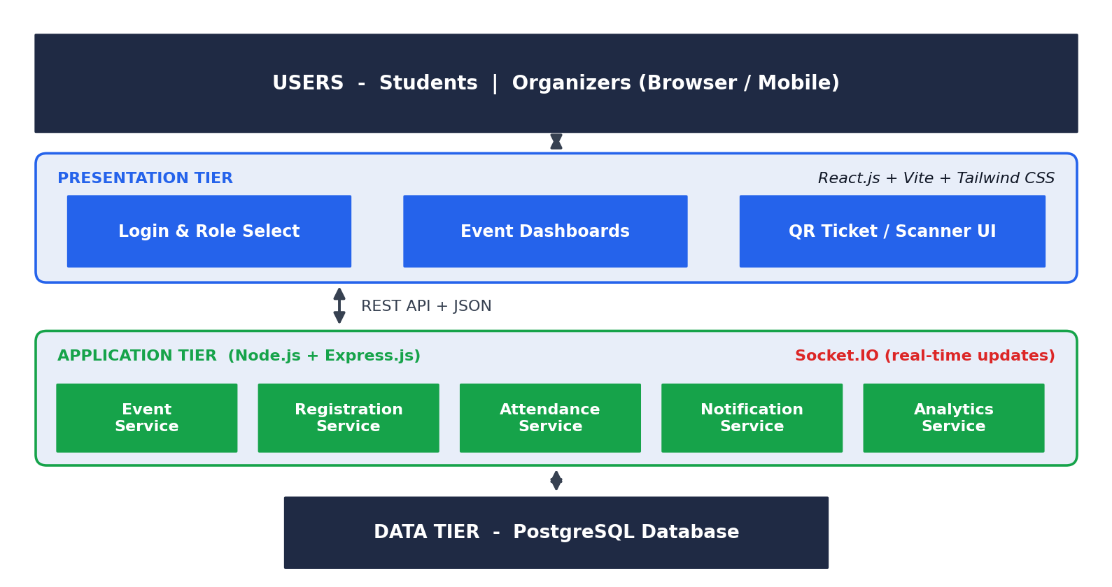
Figure 2: Three-tier system architecture with real-time layer
The tiers are independent: the frontend knows only the API address and the JSON format, and the database is accessed only by the backend services. This modular design allows each service to be scaled independently and isolates faults, so a problem in one service, for example notifications, does not stop event creation or QR check-in.

f. Use Cases
The system has two actors. The Student logs in, browses events, registers, downloads the QR ticket and views notifications. The Organizer logs in, creates and publishes events, scans QR tickets for check-in, views the live dashboard and tracks attendance. Figure 3 shows these use cases.
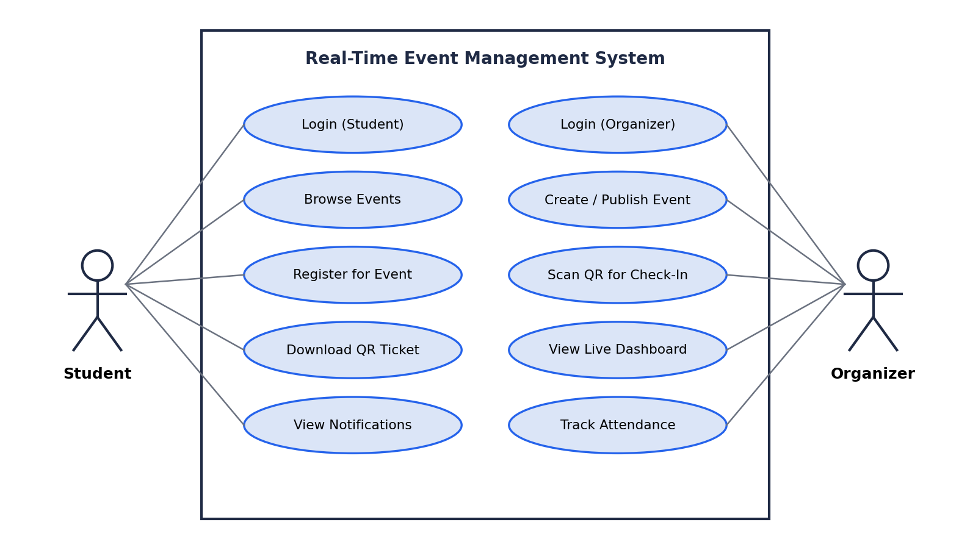
Figure 3: Use-case diagram

g. Database Design
The database has five tables, shown in the entity-relationship diagram in Figure 4. A user (organiser) can create many events, and an event can have many registrations. A student can appear in many registrations over time, but only one confirmed registration is allowed per event. Each registration has at most one attendance record, which is created when its QR ticket is scanned. Notifications are stored per user so that the unread counter shown in the interface can be calculated.
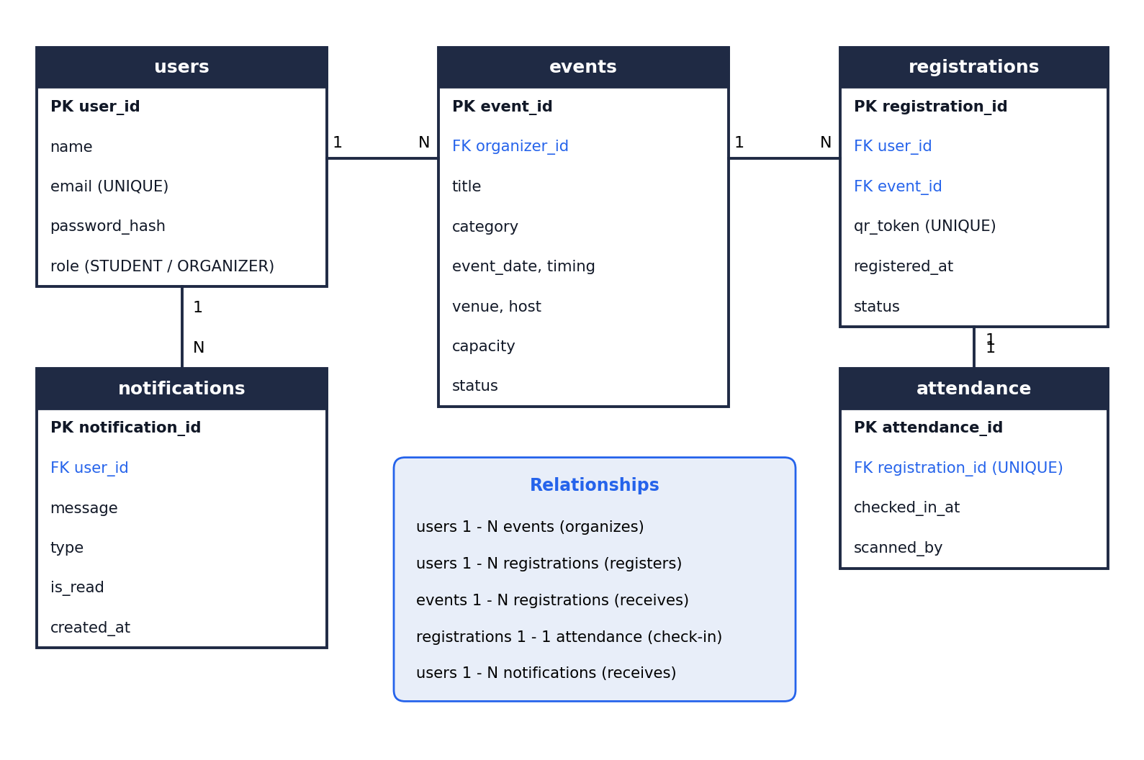
Figure 4: Entity-relationship diagram of the database
The users table, described in Table 6, stores the accounts of both roles. The email address is unique, and the role column decides which portal (Student or Organizer) the user may enter.
Table 6: Structure of the users table
Column | Description | Constraint
user_id | Auto-generated identifier | Primary key
name | Full name, for example Aarav Sharma | Not null
email | Login email, for example student@campus.edu | Unique, not null
password_hash | Stored password hash | Not null
role | STUDENT or ORGANIZER | Not null, CHECK

The events table, described in Table 7, stores the data entered in the Create New Campus Event form: title, category, seat capacity, date, timing, venue, host and description. The status column holds the lifecycle state, and the interface shows it as a label such as PUBLISHED on every event card.
Table 7: Structure of the events table
Column | Description | Constraint
event_id | Auto-generated identifier | Primary key
organizer_id | User who created the event | Foreign key to users
title | Event title | Not null
category | Artificial Intelligence, Cybersecurity, Workshop and so on | Not null
event_date | Date of the event | Not null
timing | Time range, for example 10:00 AM - 04:00 PM | Not null
venue | Venue or location | Not null
host_dept | Hosting department (default: Central Event Committee) | Not null
description | Overview, topics and guidelines | Optional
capacity | Number of seats (default 100 in the form) | Not null, CHECK > 0
status | DRAFT, PUBLISHED, CANCELLED or COMPLETED | Not null, CHECK

The registrations table, described in Table 8, links students to events. The qr_token column holds the random, unique value that is encoded into the QR ticket. Instead of deleting a registration when a student withdraws, its status is changed to CANCELLED, which keeps history and lets the seat be reused.
Table 8: Structure of the registrations table
Column | Description | Constraint
registration_id | Auto-generated identifier | Primary key
user_id | Student who registered | Foreign key to users
event_id | Event registered for | Foreign key to events
qr_token | Random value encoded in the QR ticket | Unique, not null
registered_at | Date and time of registration | Default current time
status | CONFIRMED or CANCELLED | Not null, CHECK

The attendance table, described in Table 9, records the check-in. Because registration_id is unique in this table, a ticket can be admitted only once, even if the same QR code is scanned twice.
Table 9: Structure of the attendance table
Column | Description | Constraint
attendance_id | Auto-generated identifier | Primary key
registration_id | Registration being checked in | Foreign key, unique
checked_in_at | Time of check-in | Default current time
scanned_by | Organizer who scanned the ticket | Foreign key to users

The notifications table, described in Table 10, stores the alerts shown under the bell icon of the interface, such as registration confirmations, event updates, reminders and check-in messages.
Table 10: Structure of the notifications table
Column | Description | Constraint
notification_id | Auto-generated identifier | Primary key
user_id | Recipient | Foreign key to users
message | Text shown to the user | Not null
type | REGISTRATION, UPDATE, REMINDER or CHECKIN | Not null, CHECK
is_read | Whether the user has opened it | Default false
created_at | Time of creation | Default current time

h. Normalisation and Integrity Constraints
The tables were checked against the normal forms. All columns hold single, atomic values, so the tables are in first normal form. In every table the primary key is a single column, so no non-key attribute depends on only a part of a key, which gives second normal form. In each table every non-key attribute depends only on the key (and on candidate keys such as email or qr_token), so the tables are also in third normal form. The name of a student and the title of an event are stored only once, in their own tables, and are brought into dashboards and tickets by joins, which removes update anomalies.
Integrity is protected at four levels: primary keys identify rows, foreign keys ensure that a registration refers only to an existing student and event, unique constraints stop duplicate emails and QR tokens, and CHECK constraints keep values such as role, status and capacity in their valid range. A partial unique index on registrations(user_id, event_id) restricted to CONFIRMED rows gives a final guarantee that a student cannot hold two confirmed registrations for one event, even if application code were bypassed (see Listing 1).

i. Indexes and Query Design
Primary keys and unique constraints automatically create indexes, so lookups by user_id, event_id, email and qr_token are fast. The QR check-in lookup uses the unique index on qr_token, and the capacity check uses an index on registrations(event_id). Queries use explicit column lists and parameter placeholders, avoid SELECT *, and use joins and COUNT with FILTER so that the database, not the application, does the aggregation for the analytics dashboard.

j. Data Flow
Figure 5 is the level 0 data flow diagram. Students and organisers send requests and form data to the system and receive tickets, alerts and live analytics. The system exchanges queries and result rows with the PostgreSQL database.
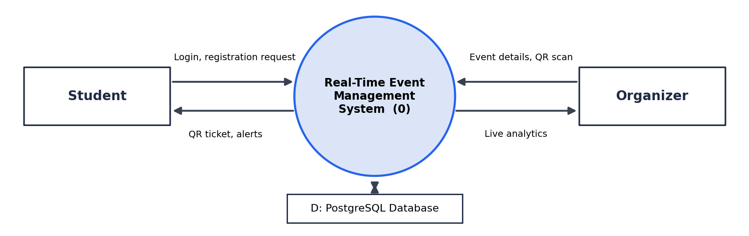
Figure 5: Level 0 data flow diagram (context diagram)
Figure 6 expands the system into five processes: authentication, event management, registration with QR generation, QR check-in, and notification with analytics. Each process reads from or writes to the users (D1), events (D2), registrations (D3), attendance (D4) and notifications (D5) data stores. The dashed flow shows live updates pushed to the dashboards through Socket.IO.
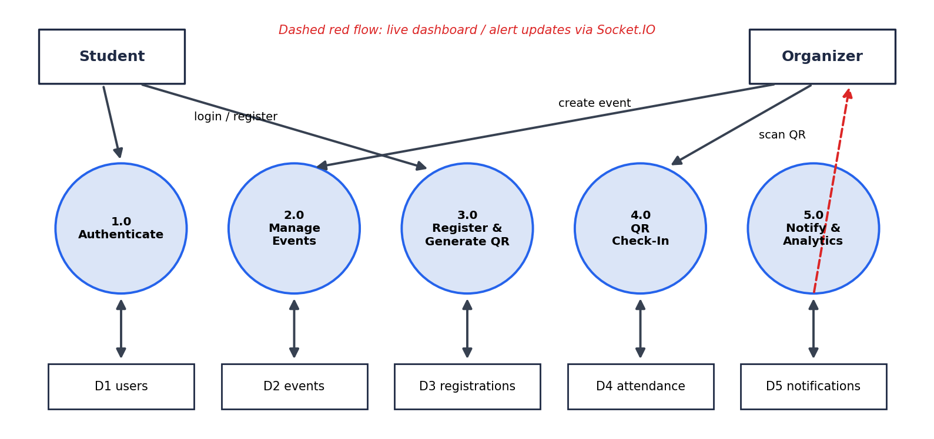
Figure 6: Level 1 data flow diagram

k. Module Description
The application is organised into the modules listed in Table 11. Each module has a matching backend service and matching frontend screens, which keeps the code easy to follow.
Table 11: Implementation modules and status
Module | Function | Status
Event Management | Create, publish and list events; manage event information across the lifecycle | Completed
Registration and Capacity | Register participants, enforce seat limits, prevent duplicates, issue QR tickets | Completed
QR Attendance | Generate QR tickets and scan them at the venue to record attendance | Completed
Notifications | Registration confirmations, event updates, reminders and check-in alerts | Completed
Analytics Dashboard | Registrations, attendance, capacity and event performance for organisers | Completed
Database Management | Centralised PostgreSQL storage through the backend services | Integrated

Event Management. The organiser opens the Create New Campus Event form, fills in the title, category, seat capacity, date, timing, venue, host department and description, and presses Publish Event. The frontend sends the values to the events endpoint, the backend validates them and inserts the row, and the new event immediately appears on the student portal as a card with its category and PUBLISHED label.
Registration and Capacity. A logged-in student presses register on an event card. The backend locks the event row, checks that the event is open, that the student is not already registered and that confirmed registrations are fewer than the capacity, and only then inserts the registration. If any check fails, nothing is saved and a clear message is returned.
QR Attendance. For every confirmed registration the system creates a random token and shows it as a QR ticket that the student can download. At the venue the organiser scans the QR code with the scanner screen. The backend looks the token up, verifies the registration and records the attendance only if the ticket has not been used before.
Notifications. Registration confirmations, event updates, reminders and check-in messages are stored in the notifications table and pushed to the browser. The bell icon in the top bar shows the number of unread notifications.
Analytics Dashboard. The dashboard summarises registrations, attendance, capacity use and overall event performance. Because the figures are refreshed through Socket.IO, the organiser sees them change as students register and as tickets are scanned.
Database Management. All persistent data of the other modules is managed through the backend services and stored in PostgreSQL, so that every portal works on the same, consistent data.

l. Backend Design
The backend is a single Express application that exposes the endpoints listed in Table 12. Every endpoint validates its input, runs parameterised SQL through a connection pool and returns a common JSON format with a success flag, a message or data field, and an HTTP status code that reflects the outcome. Routes that change data check the role of the logged-in user, so that only organisers can create events or scan tickets and only students can register.
Table 12: REST API endpoints
Method | Endpoint | Purpose
GET | /api/health | Check that Express and PostgreSQL are connected
POST | /api/auth/login | Authenticate a user for the selected role and return the session
GET | /api/events | List published events with remaining seats
POST | /api/events | Create and publish an event (Organizer)
POST | /api/registrations | Register the logged-in student for an event (Student)
GET | /api/registrations/my | List the student's registrations and QR tickets
POST | /api/attendance/scan | Verify a QR token and record attendance (Organizer)
GET | /api/notifications | List notifications and the unread count of the user
PATCH | /api/notifications/:id/read | Mark a notification as read
GET | /api/dashboard/summary | Registrations, attendance and capacity figures for organisers

The endpoint list is representative of the implemented services; the exact route names may differ slightly in the source code. The dashboard endpoint computes its figures with aggregate SQL: the number of events, total capacity, confirmed registrations and checked-in attendees, grouped by event, using COUNT with a FILTER clause so that the database does the calculation in a single query.

m. API Specification
Table 13 gives the request and response details of the endpoints that change or return the most important data. All responses are JSON objects with a success field; error responses also contain a message field that the frontend shows directly in a notification.
Table 13: Request and response details of the main endpoints
Endpoint | Request data | Successful response | Error responses
POST /api/auth/login | email, password, role | 200 and user with role | 401 invalid credentials
GET /api/events | None | 200 and list of events | 500
POST /api/events | title, category, capacity, event_date, timing, venue, host_dept, description | 201 and the saved event | 400 missing field; 403 not an organizer
POST /api/registrations | event_id | 201 and registration with qr_token | 404 event; 409 full or duplicate
POST /api/attendance/scan | qr_token | 200 and attendee details | 404 invalid QR; 409 already used
GET /api/dashboard/summary | None | 200 and totals per event | 403; 500

The status codes used by the API are summarised in Table 14.
Table 14: HTTP status codes used by the API
Code | Meaning | Used when
200 | OK | Data returned, login accepted or attendance recorded
201 | Created | Event or registration created
400 | Bad request | Missing or invalid field
401 | Unauthorised | Invalid email or password
403 | Forbidden | The role of the user is not allowed to perform the action
404 | Not found | Event or QR token not found; unknown endpoint
409 | Conflict | Event full, duplicate registration or QR ticket already used
500 | Server error | Unexpected database or server error

n. Registration, Capacity Control and QR Check-In Logic
Registration is the operation that must never over-book an event, even if many students press the button at the same moment. The registration endpoint therefore runs all its checks and the insert inside one database transaction. It first locks the event row with SELECT ... FOR UPDATE, which makes concurrent requests for the same event wait for each other. It then checks that the event is published, that the student has no confirmed registration for it and that the number of confirmed registrations is smaller than the capacity. Only if all checks succeed does it insert the registration with a newly generated random qr_token and commit. Every failed check rolls the transaction back and returns a specific message.
QR check-in follows the flow in Figure 7. The scanner sends the token to the server, which checks that it exists, that the registration is confirmed and that it has not been checked in before. Only then is the attendance row inserted, followed by a live update and a notification. A forged, cancelled or reused ticket is rejected with a clear message.
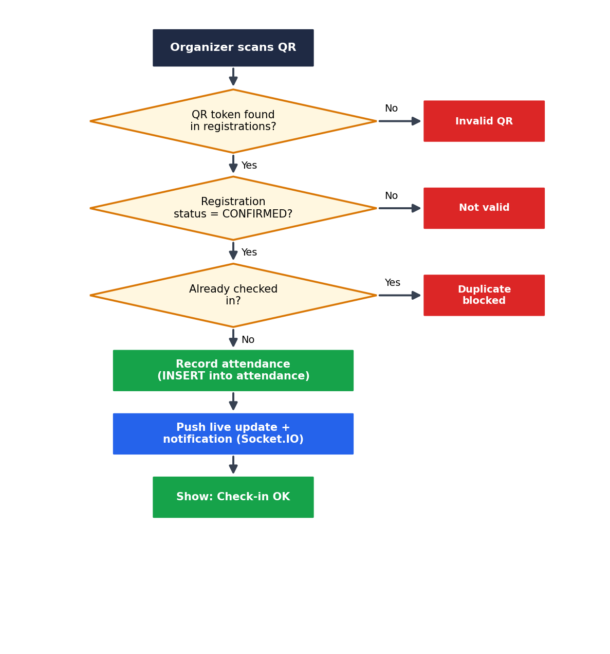
Figure 7: Flowchart of the QR check-in process
The sequence of messages for a registration and a later check-in is shown in Figure 8.
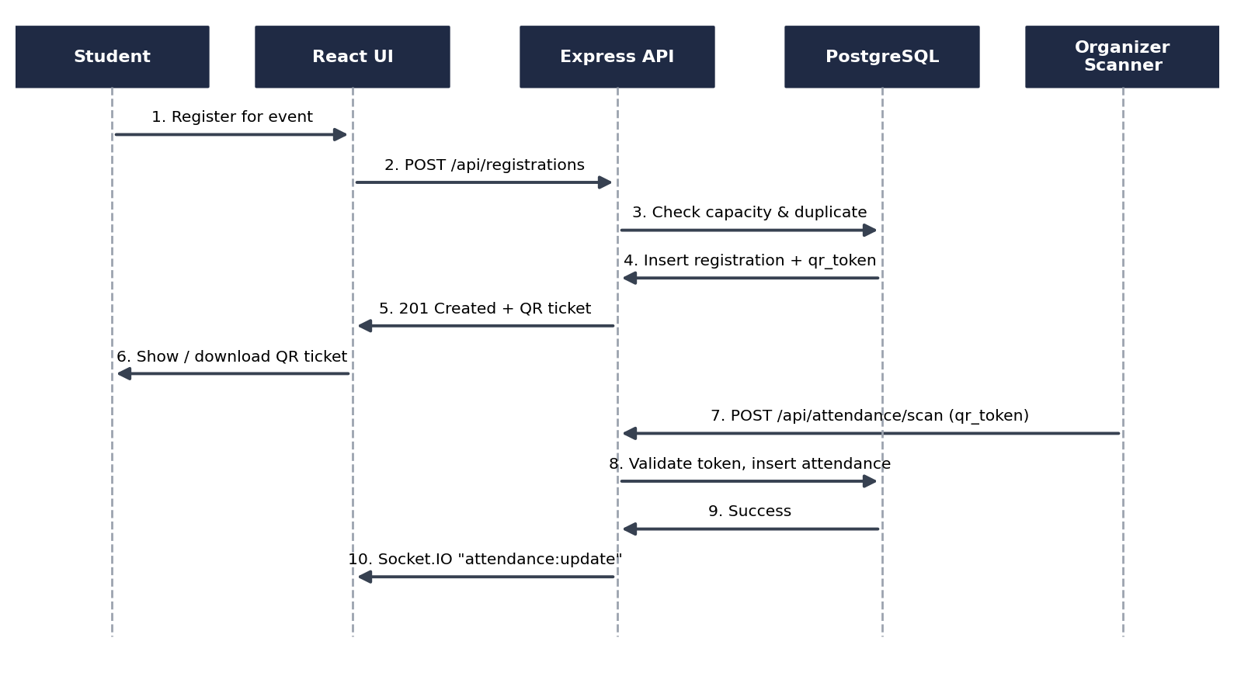
Figure 8: Sequence diagram of registration and QR check-in
The two operations also illustrate the ACID properties. Atomicity: the checks and the insert belong to one transaction that is rolled back if any check fails. Consistency: the rules on capacity, duplicates and ticket use are verified before the row is inserted and are verified again by the database constraints. Isolation: the row lock on the event serialises concurrent registrations for the same event, so two requests cannot both take the last seat. Durability: after commit, PostgreSQL has written the change to its transaction log, so the registration or attendance survives a restart.

o. Real-Time Updates with Socket.IO
The words "real-time" in the project name refer to the Socket.IO layer. When the browser loads, the frontend opens a WebSocket connection to the server; the top bar shows the state of this connection, for example "Connecting Live Stream..." while it is being established. After a successful registration, check-in or notification, the server emits an event such as registration:update, attendance:update or notification:new. The React application listens for these events and updates its state, so the organiser dashboard, the seat counters and the notification badge change without reloading the page. If the connection is lost, the frontend falls back to loading the data again through the REST API.

p. Frontend Design
The frontend is a single-page application written with React function components and hooks, built with Vite and styled with Tailwind CSS. It has two role-based portals that share one layout: a top bar and a content area. The selected role and page are held in state, so changing screens does not reload the browser.
The login screen (EventHub Portal Access) has two tabs, Student Login and Organizer Login, each with its own description, email and password fields and a one-click demo login for quick demonstrations. The top bar of the main application shows the portal name, the state of the live stream, a running clock, the name and role of the logged-in user, a Switch Role button, a logout button, the notification bell with an unread badge and a dark / light theme toggle. Events are shown as cards with a coloured banner, a category tag and a status label. The organiser portal adds the Create New Campus Event form, the QR scanner screen and the analytics dashboard.
Colour and layout carry meaning: each category has its own banner colour, status labels such as PUBLISHED are shown in green, the live stream indicator turns green when the connection is active, and unread notifications are shown in red. Immediate feedback is given by notifications after each action, so that the user always knows what the system is doing. The interface is dark by default for comfortable use during evening events and can be switched to a light theme.

q. Implementation of Key Parts
The following listings show the most important parts of the implementation in a shortened form. Listing 1 is the SQL schema that the application expects, Listing 2 is the core of the registration endpoint, Listing 3 is the QR scan endpoint and Listing 4 is the real-time listener of the frontend. The listings are representative and intended to explain the design; they are not a complete copy of the project source.
Listing 1: PostgreSQL schema used by the application (representative DDL)
CREATE TABLE users (
user_id SERIAL PRIMARY KEY,
name VARCHAR(100) NOT NULL,
email VARCHAR(100) UNIQUE NOT NULL,
password_hash TEXT NOT NULL,
role VARCHAR(10) NOT NULL CHECK (role IN ('STUDENT','ORGANIZER'))
);

CREATE TABLE events (
event_id SERIAL PRIMARY KEY,
organizer_id INT NOT NULL REFERENCES users(user_id),
title VARCHAR(150) NOT NULL,
category VARCHAR(50) NOT NULL,
event_date DATE NOT NULL,
timing VARCHAR(40) NOT NULL,
venue VARCHAR(120) NOT NULL,
host_dept VARCHAR(100) NOT NULL DEFAULT 'Central Event Committee',
description TEXT,
capacity INT NOT NULL CHECK (capacity > 0),
status VARCHAR(12) NOT NULL DEFAULT 'PUBLISHED'
CHECK (status IN ('DRAFT','PUBLISHED','CANCELLED','COMPLETED'))
);

CREATE TABLE registrations (
registration_id SERIAL PRIMARY KEY,
user_id INT NOT NULL REFERENCES users(user_id),
event_id INT NOT NULL REFERENCES events(event_id),
qr_token VARCHAR(64) UNIQUE NOT NULL,
registered_at TIMESTAMP NOT NULL DEFAULT NOW(),
status VARCHAR(10) NOT NULL DEFAULT 'CONFIRMED'
CHECK (status IN ('CONFIRMED','CANCELLED'))
);

-- one CONFIRMED registration per student per event
CREATE UNIQUE INDEX one_active_registration
ON registrations(user_id, event_id) WHERE status = 'CONFIRMED';

CREATE TABLE attendance (
attendance_id SERIAL PRIMARY KEY,
registration_id INT UNIQUE NOT NULL REFERENCES registrations(registration_id),
checked_in_at TIMESTAMP NOT NULL DEFAULT NOW(),
scanned_by INT REFERENCES users(user_id)
);

CREATE TABLE notifications (
notification_id SERIAL PRIMARY KEY,
user_id INT NOT NULL REFERENCES users(user_id),
message TEXT NOT NULL,
type VARCHAR(12) NOT NULL,
is_read BOOLEAN NOT NULL DEFAULT FALSE,
created_at TIMESTAMP NOT NULL DEFAULT NOW()
);

Listing 2: Core of the registration endpoint (Express, shortened)
router.post('/registrations', requireRole('STUDENT'), async (req, res) => {
const { event_id } = req.body;
const client = await pool.connect();
try {
await client.query('BEGIN');
// lock the event row so concurrent requests wait
const ev = await client.query(
'SELECT event_id, capacity, status FROM events WHERE event_id = $1 FOR UPDATE',
[event_id]);
if (!ev.rows.length) {
await client.query('ROLLBACK');
return res.status(404).json({ success: false, message: 'Event not found' });
}
if (ev.rows[0].status !== 'PUBLISHED') {
await client.query('ROLLBACK');
return res.status(400).json({ success: false, message: 'Event is not open' });
}
const dup = await client.query(
"SELECT 1 FROM registrations WHERE user_id=$1 AND event_id=$2 AND status='CONFIRMED'",
[req.user.id, event_id]);
if (dup.rows.length) {
await client.query('ROLLBACK');
return res.status(409).json({ success: false, message: 'Already registered' });
}
const cnt = await client.query(
"SELECT COUNT(*)::int AS taken FROM registrations WHERE event_id=$1 AND status='CONFIRMED'",
[event_id]);
if (cnt.rows[0].taken >= ev.rows[0].capacity) {
await client.query('ROLLBACK');
return res.status(409).json({ success: false, message: 'Event is full' });
}
const token = crypto.randomUUID();
const ins = await client.query(
"INSERT INTO registrations (user_id, event_id, qr_token, status) " +
"VALUES ($1,$2,$3,'CONFIRMED') RETURNING *",
[req.user.id, event_id, token]);
await client.query('COMMIT');
io.emit('registration:update', { event_id });
res.status(201).json({ success: true, message: 'Registration successful',
data: ins.rows[0] });
} catch (err) {
await client.query('ROLLBACK');
res.status(500).json({ success: false, message: 'Server error' });
} finally {
client.release(); // always free the connection and its locks
}
});

Listing 3: QR scan endpoint (Express, shortened)
router.post('/attendance/scan', requireRole('ORGANIZER'), async (req, res) => {
const { qr_token } = req.body;
const reg = await pool.query(
"SELECT r.registration_id, r.status, u.name, e.title " +
"FROM registrations r JOIN users u ON u.user_id = r.user_id " +
"JOIN events e ON e.event_id = r.event_id WHERE r.qr_token = $1", [qr_token]);
if (!reg.rows.length) return res.status(404).json({ success: false, message: 'Invalid QR code' });
if (reg.rows[0].status !== 'CONFIRMED')
return res.status(409).json({ success: false, message: 'Registration is not valid' });
try {
await pool.query(
"INSERT INTO attendance (registration_id, scanned_by) VALUES ($1,$2)",
[reg.rows[0].registration_id, req.user.id]);
} catch (err) {
if (err.code === '23505') // unique violation: already checked in
return res.status(409).json({ success: false, message: 'Ticket already used' });
throw err;
}
io.emit('attendance:update', { event: reg.rows[0].title });
res.json({ success: true, message: 'Check-in successful', data: reg.rows[0] });
});

Listing 4: Real-time listener in the React frontend (shortened)
useEffect(() => {
const socket = io(API_URL);
socket.on('connect', () => setLive(true));
socket.on('disconnect', () => setLive(false));
socket.on('registration:update', () => loadEvents());
socket.on('attendance:update', () => loadDashboard());
socket.on('notification:new', () => setUnread(n => n + 1));
return () => socket.disconnect();
}, []);

r. Security and Configuration
Database settings (host, port, name, user and password) and other secrets are read from environment variables loaded from a .env file, so that credentials are not written into the program logic, and the .env file is excluded from version control through .gitignore. All SQL statements use placeholders instead of string concatenation, which protects against SQL injection. Routes that modify data check the role of the logged-in user on the server, so that hiding a button in the interface is never the only protection. QR tokens are long random values, so they cannot be guessed, and each ticket can be used only once. For a production deployment, hashed passwords with strong policies, restricted CORS origins, HTTPS and removal of the demo login would also be required, as listed in the future work.

3. Experiments

a. Experimental Setup
The system was run and tested on a local development machine, and the frontend build was also deployed for demonstration on Netlify. The React frontend was started with the Vite development server, the Express backend with Node.js, and both were connected to a PostgreSQL database. Table 15 lists the environment.
Table 15: Experimental environment
Item | Details
Hardware | Laptop / desktop computer, 64-bit
Browser | Google Chrome on desktop and a mobile browser (developer tools used to observe requests)
Frontend | React.js, Vite and Tailwind CSS; production build hosted on Netlify for the demonstration
Backend | Node.js with Express.js and Socket.IO
Database | PostgreSQL
Tools | VS Code, Git and GitHub, browser Network tab, API testing client

b. Test Data
Sample data was loaded to test every module realistically. Table 16 summarises it. The login page offers one-click demo accounts for two students, Aarav Sharma (student@campus.edu) and Sneha Patel (sneha@campus.edu), and a separate organizer account. Sample events were published in several categories, for example the Cloud & DevOps Engineering Workshop (category Workshop) and the Cyber Defense & Security Summit (category Cybersecurity), both in the PUBLISHED state.
Table 16: Sample data used in the experiments
Item | Details
Student accounts | Aarav Sharma, Sneha Patel (demo accounts)
Organizer account | One organizer account with access to the Organizer portal
Events | Several published events in different categories, for example Workshop and Cybersecurity
Capacity test event | An event with a very small seat capacity, created to test the capacity rule
Registrations and tickets | Created through the application, each with its own QR ticket
Notifications | Generated automatically by registrations, updates and check-ins

c. Test Plan
Testing was functional (black-box). Each feature was exercised through the user interface, and the behaviour of the API was observed in the browser Network tab. Both valid inputs and invalid or conflicting inputs were used, because the correctness of a registration and attendance system depends mainly on how it handles invalid cases. Ten test cases were designed, one for each module or rule. For each test case the steps were performed, the expected result was written down in advance and the actual result was compared with it.
- Test 1: Event Creation. Create an event with the Create New Campus Event form. Expected: the event is created successfully and appears as a card.
- Test 2: Participant Registration. Register a student for a published event. Expected: the participant is registered and receives a QR ticket.
- Test 3: Capacity Validation. Try to register for an event whose seats are exhausted. Expected: capacity is enforced and the request is rejected.
- Test 4: QR Verification. Scan a valid QR ticket. Expected: a valid QR records attendance.
- Test 5: Duplicate Registration. Register the same student for the same event twice. Expected: the duplicate is prevented.
- Test 6: Database Operation. Create, read and verify records. Expected: data is stored and retrieved correctly.
- Test 7: API Request. Call the main endpoints. Expected: the correct response and status code is returned.
- Test 8: Dashboard Update. Register and check in a student while the dashboard is open. Expected: updated data is reflected.
- Test 9: Notification. Perform an action that should alert the user. Expected: a notification is triggered and the unread counter changes.
- Test 10: Analytics. Compare the dashboard with the stored data. Expected: correct metrics are displayed.

d. Detailed Test Procedures
Table 17 gives the input and the steps used for each test case, so that the experiments can be repeated by anyone who has the sample data.
Table 17: Test procedures
No. | Steps and input | Expected outcome
1 | Log in as organizer; open Create New Campus Event; enter title, category, capacity, date, timing and venue; press Publish Event | Event created; card shown with PUBLISHED label
2 | Log in as student; press register on a published event | Registration saved; QR ticket available
3 | Create an event with capacity 1; register one student; try a second student | Second request rejected (409); message that the event is full
4 | Open the scanner as organizer; scan the QR ticket of a registered student | Attendance recorded; success message shown
5 | Register the same student for the same event again | Rejected (409); message that the student is already registered
6 | Create events and registrations, reload the application | Data is still present and identical after reload
7 | Call the events, registration, scan and dashboard endpoints | Correct JSON and status codes (200, 201, 404, 409)
8 | Keep the dashboard open; register a student and scan a ticket | Counters change without reloading the page
9 | Register for an event and check the bell icon | New notification appears; unread count increases
10 | Compare registrations, attendance and capacity on the dashboard with the database | Figures match the stored data

e. API Request and Response Examples
The following examples show typical API exchanges observed during testing. The first is a successful registration; the second is a rejected registration for a full event.
Listing 5: Successful registration (POST /api/registrations)
Request body:
{ "event_id": 2 }

Response (HTTP 201 Created):
{
"success": true,
"message": "Registration successful",
"data": {
"registration_id": 11, "user_id": 1, "event_id": 2,
"qr_token": "c1f0a7d2-5b1e-4d0e-9c53-7b2f6f1e8a10",
"status": "CONFIRMED"
}
}

Listing 6: Rejected registration for a full event
Request body:
{ "event_id": 3 }

Response (HTTP 409 Conflict):
{
"success": false,
"message": "Event is full"
}

The values in the listings are illustrative examples of the response format.

f. Result Observation
The behaviour of the system was observed in the browser Network tab and on the screens. Because the system runs on the same machine as the database during development and the data set is small, responses are fast and no delay was noticed when loading events, registering, scanning a ticket or refreshing the dashboard. These observations are indicative of a local environment and should not be read as a benchmark of a production deployment.

g. Frontend Verification
In addition to the functional tests, the frontend was checked visually. The login page was tested with both role tabs and with the one-click demo login. The student home page, the organizer form, the QR ticket, the QR scanner and the dashboard were opened in turn. The theme toggle, the Switch Role button, the notification bell and the live stream indicator were checked, and the layout was checked on a mobile-width window. Screenshots of the working application are given in Section 4.

4. Results

a. Functional Results
The system behaved as expected in all ten test cases, as listed in Table 18. Valid operations succeeded, and every invalid operation was rejected with a clear message without changing the stored data. In particular, the conflict situations (full event and duplicate registration) are stopped by the server even though the interface already discourages them, which confirms that the validation does not depend on the frontend alone.
Table 18: Functional test cases and results
Test Case | Expected Result | Actual Result | Status
Event Creation | Event created successfully | Event created | Pass
Participant Registration | Participant registered | Registered, QR ticket issued | Pass
Capacity Validation | Capacity enforced | Request rejected when full | Pass
QR Verification | Valid QR records attendance | Attendance recorded | Pass
Duplicate Registration | Duplicate prevented | Duplicate rejected | Pass
Database Operation | Data stored / retrieved correctly | Correct | Pass
API Request | Correct response returned | Correct | Pass
Dashboard Update | Updated data reflected | Reflected live | Pass
Notification | Notification triggered | Triggered | Pass
Analytics | Correct metrics displayed | Correct | Pass

b. Summary of Results
Table 19 summarises the measurable results. All ten test cases passed, giving a 0% error rate and a 100% pass rate. The core modules (Event Management, Registration and Capacity, and QR Attendance) are implemented and integrated, and the workflow Frontend, Backend / API, Database, Dashboard is fully operational with real-time data synchronisation.
Table 19: Result summary
Metric | Result
Modules implemented | 6 (Event Management, Registration and Capacity, QR Attendance, Notifications, Analytics Dashboard, Database Management)
Test cases executed | 10
Successful test cases | 10 (100%)
Error rate | 0%
User roles / portals | 2 (Student, Organizer)
Real-time updates | Dashboard and notifications update without reload (Socket.IO)
Over-booking or duplicate registration observed | None

c. Description of the Screens
Table 20 lists the screens that make up the user journey, from authentication through event creation, registration, QR check-in and live reporting. The main screens are shown in Figure 9 to Figure 14.
Table 20: Screens of the working application
# | Screen | Purpose
1 | Login Page | Role-based sign-in for Students and Organizers, with one-click demo login
2 | Home Page | Landing view of the portal with published events
3 | Main Application | Top bar with live status, clock, user, role switch, notifications and theme toggle; event cards
4 | Event Creation Form | Organizer form to publish a new campus event
5 | Registration Page | Student registers for an event and receives a QR ticket
6 | QR Attendance Check-In | Organizer scans tickets and records attendance
7 | Dashboard | Registrations, attendance, capacity and event performance
8 | Output / Results Page | Final status and attendance results of an event

Login page. The EventHub Portal Access dialog asks the user to select a role to reach a dedicated dashboard (Figure 9). The Student Login tab explains that students can sign in to register for upcoming events and download their QR tickets, and asks for the student email and password. A Quick 1-Click Demo Login section lists the demo students Aarav Sharma and Sneha Patel. The Organizer Login tab leads to the organizer portal.
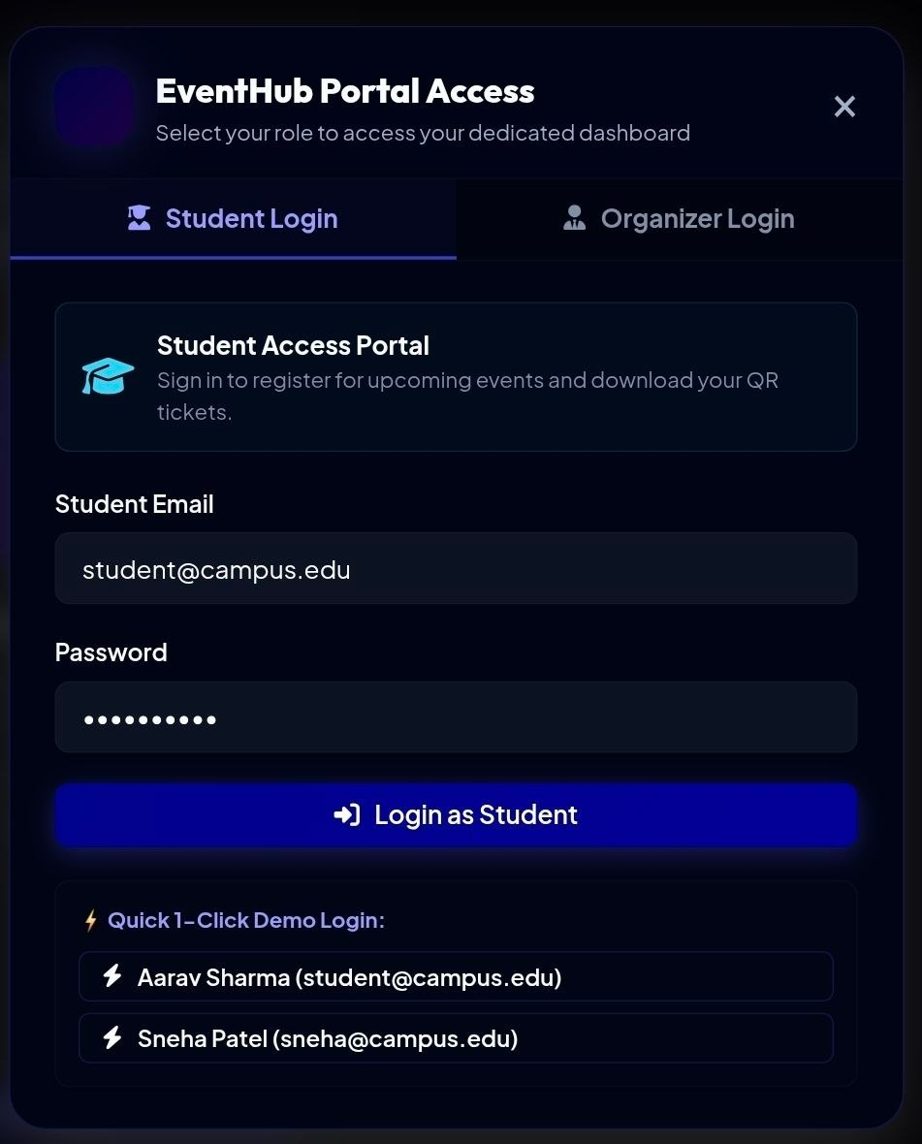
Figure 9: EventHub Portal Access: role-based login page
Home page and main application. After login the student sees the portal top bar and the published events (Figure 10). The top bar shows the Student Portal label, the live stream status, a running clock, the name and role of the user (here Aarav Sharma, Student), the Switch Role button, the logout icon, the notification bell with an unread badge of 3 and the theme toggle. Each event is a card with a coloured banner, a category tag (Workshop, Cybersecurity) and a PUBLISHED status label, followed by the title and a short description, for example Cloud & DevOps Engineering Workshop and Cyber Defense & Security Summit.
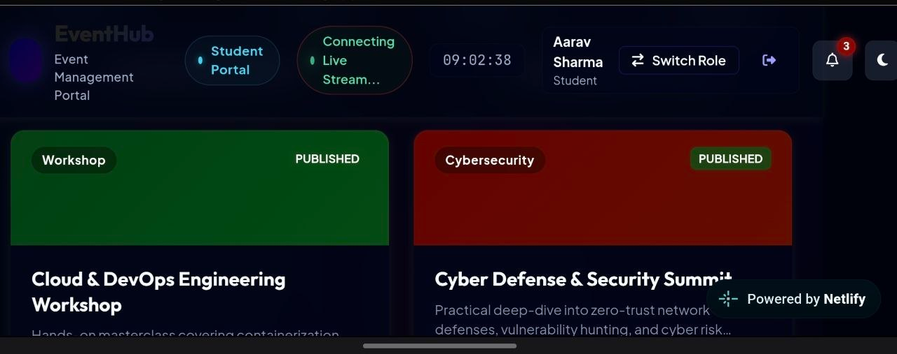
Figure 10: Student portal home page showing published events
Event creation form. The organizer opens the Create New Campus Event form (Figure 11). Required fields are marked with an asterisk: Event Title, Category (a drop-down, with Artificial Intelligence as the first choice), Seat Capacity (default 100), Event Date, Timing, and Venue / Location. The Host / Organizing Department field defaults to Central Event Committee, and an optional Event Description accepts the overview, key topics, eligibility or guidelines. The Cancel button closes the form and the Publish Event button saves the event and makes it visible to students.
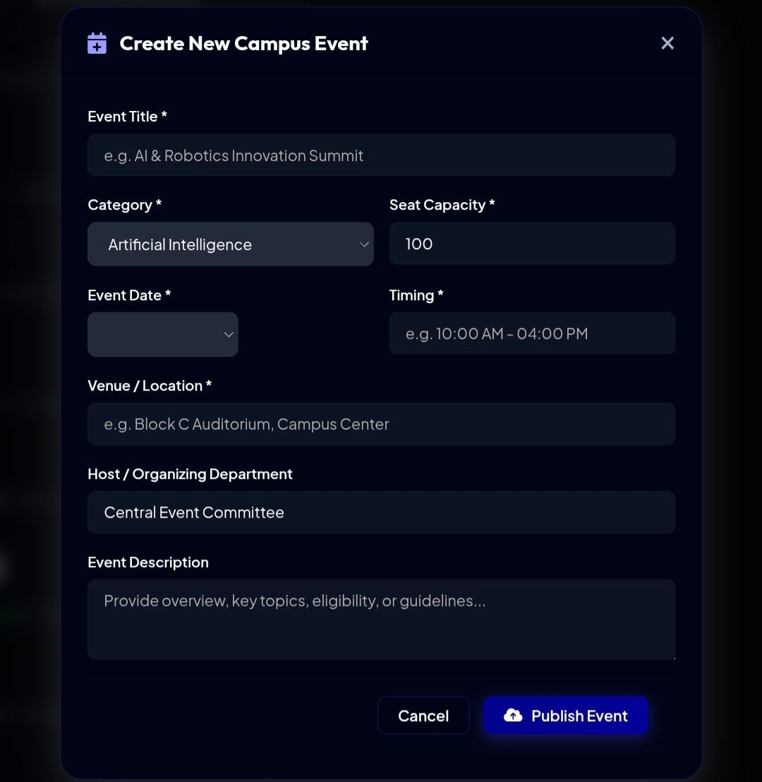
Figure 11: Create New Campus Event form (organizer)
Table 21: Before and after: manual process versus the developed system
Aspect | Before | After
Event management | Disconnected processes | Centralised platform
Attendance recording | Manual, error-prone | Digital, QR-based
Data tracking | Difficult, scattered | Centralised tracking
Event visibility | Limited visibility | Real-time dashboard
Seat control | Counted by hand | Enforced automatically on the server

e. Discussion
The results show that moving the registration and attendance rules from the person to the server is the most valuable part of the system. The row lock on the event, the checks for duplicates and capacity, and the single transaction together guarantee that the data stays consistent. The unique QR token and the unique attendance record make the attendance trustworthy, because a ticket can be used only once and cannot be guessed. Keeping cancelled registrations as history instead of deleting them preserves a complete record and also lets the seat be reused.
The Socket.IO layer changes the way the organiser uses the system: instead of refreshing a report, the organiser watches the registrations and attendance grow during the event. The separation between the React frontend and the Express API also proved useful, since the API can be tested without the interface and the interface can be restyled without touching the business rules. The main limitations observed are the demonstration-level authentication, the absence of payment and certificate features, and dependence on a network connection for live updates, all of which are addressed in the future work.
The three qualities highlighted in the project review, accuracy (validated data and verified tickets), efficiency (quick registration and check-in) and scalability (modular services and a relational database), were all supported by the results of the tests.

f. Working Procedure (User Guide)
This section explains how the system is used once the backend and frontend are running.
- Start the system: start the Express backend and the Vite frontend, then open the frontend address in a browser. The login dialog appears.
- Student login: select the Student Login tab, enter the email and password (or use a demo account) and press Login as Student.
- Browse and register: on the home page, open an event card and register. A confirmation notification appears and the QR ticket becomes available for download.
- Organizer login: select the Organizer Login tab and sign in. Use Switch Role to move between portals when allowed.
- Create an event: press the create button, fill the required fields and press Publish Event. The event appears for students at once.
- Check in participants: open the scanner and scan each student's QR ticket. The result is shown immediately and the dashboard updates.
- Monitor: watch the dashboard and the notification bell for live registrations, attendance and alerts.

g. Challenges Faced and Solutions
Table 22 lists the main technical problems met during development and the way they were solved.
Table 22: Challenges and solutions
Challenge | Solution
Preventing two students taking the last seat | Lock the event row with FOR UPDATE and do all checks in one transaction
Preventing a ticket from being used twice | Unique constraint on attendance.registration_id plus a check before insert
Keeping dashboards live without reloads | Socket.IO events pushed after each registration, scan and notification
Browser blocking calls from the frontend port to the backend port | Enable CORS on the API routes
Different views for Students and Organizers | Role stored with the user; role checked on the server for every protected route
Keeping history without blocking seat reuse | Change status to CANCELLED instead of deleting, and count only CONFIRMED rows

h. Lessons Learned
The team learned that correctness rules belong in the database and the backend, where every client is subject to them, and that the interface should only make the correct choice easy. Designing the tables and constraints first made every later decision, from the API routes to the screens, easier. Working with a modular structure and with Git and GitHub taught the team to divide work between frontend, backend and database, and to merge and test changes regularly. Finally, real-time features need careful handling of connection loss, so a fallback to normal API calls is important.

5. Conclusion and Future Work

a. Conclusion
In this project we designed and implemented a Real-Time Event Management System using React, Node.js with Express, PostgreSQL and Socket.IO. The application lets organisers create and publish events, lets students register within the seat capacity, issues a unique QR ticket for every registration, records attendance by QR scanning, sends notifications and shows live analytics. Server-side validation, unique constraints and row locking ensure that no event is over-booked, no student registers twice and no ticket is used twice. All ten test cases passed with a 0% error rate, so the project objectives were achieved.
The project gave the team practical experience in relational database design, SQL queries with joins and aggregation, transactions and locking, REST API design, component-based frontend development, real-time communication and the integration of all tiers into a deployed application. It also showed the value of validating data on the server instead of trusting the interface.

b. Future Work
The following enhancements are planned for the next phase.
- Authentication hardening: single sign-on with the institutional account, hashed passwords, token-based sessions and removal of the demo login in production.
- Payments: paid events, fee collection, receipts and refunds.
- Certificates: automatic e-certificates for participants who were checked in.
- Communication: email, SMS or push notifications for confirmations and reminders outside the application.
- Advanced analytics: export of reports to PDF or Excel, trend charts across events and feedback collection.
- Event features: waiting lists, event cancellation and rescheduling, team registration for competitions and multi-day events.
- Offline-tolerant check-in: a scanner mode that stores check-ins locally and synchronises when the network returns.
- Deployment: cloud hosting with a production process manager, HTTPS, automated backups and monitoring.

References
- Express.js Documentation, OpenJS Foundation. https://expressjs.com
- React Documentation, Meta Open Source. https://react.dev
- Vite Documentation, "Next Generation Frontend Tooling". https://vitejs.dev
- Tailwind CSS Documentation, Tailwind Labs. https://tailwindcss.com/docs
- Socket.IO Documentation. https://socket.io/docs
- PostgreSQL Global Development Group, PostgreSQL Documentation, including Explicit Locking. https://www.postgresql.org/docs
- node-postgres (pg) Documentation. https://node-postgres.com
- MDN Web Docs, Fetch API, WebSockets API and Cross-Origin Resource Sharing (CORS). https://developer.mozilla.org
- Netlify Documentation, "Deploy a static site". https://docs.netlify.com
- ISO/IEC 18004: Information technology, Automatic identification and data capture techniques, QR Code bar code symbology specification.
- R. Fielding, Architectural Styles and the Design of Network-based Software Architectures, PhD dissertation, University of California, Irvine (2000).
- R. Fielding and J. Reschke, Hypertext Transfer Protocol (HTTP/1.1): Semantics and Content, RFC 7231, IETF (2014).
- R. Elmasri and S. Navathe, Fundamentals of Database Systems, 7th ed., Pearson (2016).
- A. Silberschatz, H. Korth and S. Sudarshan, Database System Concepts, 7th ed., McGraw-Hill (2019).
- I. Sommerville, Software Engineering, 10th ed., Pearson (2016).
- OWASP Foundation, SQL Injection Prevention Cheat Sheet. https://cheatsheetseries.owasp.org

Appendix A: Backend Source Code (representative)
The listing below shows the structure of the Express backend: configuration, database connection, the Socket.IO server and two representative routes. Secrets such as the database password are read from the .env file and are not part of the source. The complete project is maintained in the team's GitHub repository.
server.js (shortened)
require('dotenv').config();
const express = require('express');
const http = require('http');
const cors = require('cors');
const { Server } = require('socket.io');
const { Pool } = require('pg');

const app = express();
app.use(cors());
app.use(express.json());

const pool = new Pool({
host: process.env.DB_HOST || "localhost",
port: process.env.DB_PORT || 5432,
database: process.env.DB_NAME,
user: process.env.DB_USER,
password: process.env.DB_PASSWORD, // set in the .env file
});

const server = http.createServer(app);
const io = new Server(server, { cors: { origin: "*" } });
io.on("connection", (socket) => console.log("client connected", socket.id));

// ---- health check ----
app.get("/api/health", async (req, res) => {
try {
await pool.query("SELECT 1");
res.json({ success: true, message: "Express and PostgreSQL are connected" });
} catch (err) {
res.status(500).json({ success: false, message: "Database connection failed" });
}
});

// ---- list published events with remaining seats ----
app.get("/api/events", async (req, res) => {
try {
const { rows } = await pool.query(`
SELECT e.event_id, e.title, e.category, e.event_date, e.timing,
e.venue, e.host_dept, e.description, e.capacity, e.status,
e.capacity - COUNT(r.registration_id)
FILTER (WHERE r.status = 'CONFIRMED') AS seats_left
FROM events e
LEFT JOIN registrations r ON r.event_id = e.event_id
WHERE e.status = 'PUBLISHED'
GROUP BY e.event_id
ORDER BY e.event_date`);
res.json({ success: true, data: rows });
} catch (err) {
res.status(500).json({ success: false, message: err.message });
}
});

// ---- create event (organizer) ----
app.post("/api/events", requireRole("ORGANIZER"), async (req, res) => {
const f = ["title","category","capacity","event_date","timing","venue"];
for (const k of f)
if (!req.body[k] || String(req.body[k]).trim() === "")
return res.status(400).json({ success: false, message: k + " is required" });
const b = req.body;
const { rows } = await pool.query(
"INSERT INTO events (organizer_id,title,category,event_date,timing,venue," +
"host_dept,description,capacity,status) VALUES ($1,$2,$3,$4,$5,$6,$7,$8,$9,'PUBLISHED') RETURNING *",
[req.user.id, b.title, b.category, b.event_date, b.timing, b.venue,
b.host_dept || "Central Event Committee", b.description || "", Number(b.capacity)]);
io.emit("event:new", rows[0]);
res.status(201).json({ success: true, message: "Event published", data: rows[0] });
});

// registration and scan routes: see Listings 2 and 3

server.listen(process.env.PORT || 5000, () => console.log("API running"));

Appendix B: Frontend Source Code (representative)
The listings show the main ideas of the React frontend: loading data and listening for live updates, generating a QR ticket from the token, and sending a scanned token to the server. Styling classes are omitted for readability.
App.jsx: data loading (shortened)
const loadEvents = async () => {
try {
const res = await fetch(`${API_URL}/events`);
const json = await res.json();
setEvents(json.data.map(x => ({
id: x.event_id, title: x.title, category: x.category,
date: x.event_date, timing: x.timing, venue: x.venue,
capacity: x.capacity, seatsLeft: Number(x.seats_left), status: x.status })));
} catch (err) {
notify("Backend connection error: " + err.message);
}
};

useEffect(() => { loadEvents(); }, []);

Register handler and QR ticket (shortened)
const register = async (eventId) => {
const res = await fetch(`${API_URL}/registrations`, {
method: "POST",
headers: { "Content-Type": "application/json", Authorization: `Bearer ${token}` },
body: JSON.stringify({ event_id: eventId }),
});
const json = await res.json();
notify(json.message); // success or error message
if (json.success) setTicket(json.data.qr_token);
};

// the ticket is the token rendered as a QR code image
const QrTicket = ({ token }) => (
<QRCodeCanvas value={token} size={220} includeMargin />
);

Scanner handler (organizer, shortened)
const onScan = async (decodedText) => {
const res = await fetch(`${API_URL}/attendance/scan`, {
method: "POST",
headers: { "Content-Type": "application/json", Authorization: `Bearer ${token}` },
body: JSON.stringify({ qr_token: decodedText }),
});
const json = await res.json();
setScanResult({ ok: json.success, message: json.message });
};

Appendix C: Installation and Execution Guide
- Install Node.js, npm and PostgreSQL on the computer.
- Create a database in PostgreSQL and run the schema of Listing 1 to create the tables. Insert the demo users and a few sample events.
- Open the backend folder, create a .env file with DB_HOST, DB_PORT, DB_NAME, DB_USER, DB_PASSWORD and PORT, and run: npm install, then node server.js.
- Open the frontend folder, set the API address in the environment file, and run: npm install, then npm run dev.
- Open the address printed by Vite in a browser. The EventHub login dialog appears.
- For deployment, create a production build with npm run build and upload the build folder to a static host such as Netlify; host the backend and database on a server reachable from the frontend.

Appendix D: API Test Commands
The following commands can be used to test the API from a terminal. Replace the token and identifiers with real values.
Example commands
# health check
curl http://localhost:5000/api/health

# list published events
curl http://localhost:5000/api/events

# register for event 2 (student token)
curl -X POST http://localhost:5000/api/registrations \
-H "Content-Type: application/json" -H "Authorization: Bearer <STUDENT_TOKEN>" \
-d '{"event_id": 2}'

# scan a ticket (organizer token)
curl -X POST http://localhost:5000/api/attendance/scan \
-H "Content-Type: application/json" -H "Authorization: Bearer <ORGANIZER_TOKEN>" \
-d '{"qr_token": "<TOKEN_FROM_TICKET>"}'

# dashboard summary (organizer token)
curl http://localhost:5000/api/dashboard/summary -H "Authorization: Bearer <ORGANIZER_TOKEN>"

Appendix E: Glossary
Table 23: Glossary of terms and abbreviations
Term | Meaning
API | Application Programming Interface: the set of requests the frontend can send to the backend
REST | Representational State Transfer: an API style that uses HTTP methods and resources
JSON | JavaScript Object Notation: text format used to exchange data
SPA | Single-Page Application: a web app that changes screens without reloading the page
QR code | Quick Response code: a two-dimensional barcode used here to carry the ticket token
Socket.IO | Library that provides real-time, two-way communication between browser and server
WebSocket | Protocol that keeps a connection open so the server can push data to the browser
CORS | Cross-Origin Resource Sharing: browser rule that allows one site to call an API on another origin
Transaction | A group of database operations that either all succeed or are all undone
ACID | Atomicity, Consistency, Isolation, Durability: properties of reliable transactions
FOR UPDATE | SQL clause that locks selected rows until the transaction ends
Primary key / Foreign key | Column that uniquely identifies a row / column that refers to a row of another table
RBAC | Role-Based Access Control: permissions decided by the role of the user
PBL | Project Based Learning

